**Project Report**

1. **INTRODUCTION** 
   1. Project Overview
   2. Purpose
2. **IDEATION PHASE**
   1. Problem Statement
   2. Empathy Map Canvas
   3. Brainstorming
3. **REQUIREMENT ANALYSIS**
   1. Customer Journey map
   2. Solution Requirement
   3. Data Flow Diagram
   4. Technology Stack
4. **PROJECT DESIGN** 
   1. Problem Solution Fit
   2. Proposed Solution
   3. Solution Architecture
5. **PROJECT PLANNING & SCHEDULING** 
   1. Project Planning
6. **FUNCTIONAL AND PERFORMANCE TESTING** 
   1. Performance Testing
7. **RESULTS** 
   1. Output Screenshots
8. **ADVANTAGES & DISADVANTAGES**
9. **CONCLUSION**
10. **FUTURE SCOPE**
11. **11. APPENDIX**

Source Code(if any)

Dataset Link

GitHub & Project Demo Link

**1 Introduction**

**1.1 Project Overview**

The MERN Bookstore is a comprehensive online bookstore built using the MERN (MongoDB, Express.js, React, Node.js) stack. The platform creates a seamless experience for book enthusiasts to discover, explore, and purchase books from various genres and authors.

The application features a dual-role system with distinct user types:

* **Regular Users (Customers)**: Can browse the book catalog, create accounts, add books to their cart, complete purchases, and track order history
* **Admin Users (Sellers)**: Have access to a specialized dashboard for inventory management, including adding new books, updating existing listings, and monitoring sales

The project integrates Firebase for authentication and MongoDB Atlas for database management, creating a robust and scalable infrastructure. The responsive design ensures a consistent experience across desktop and mobile devices, allowing users to shop for books anytime and anywhere.

**1.2 Purpose**

The primary purpose of this MERN Bookstore is to create an accessible and user-friendly platform connecting readers with books while providing booksellers with efficient management tools.

The key objectives of this MERN Bookstore project are:

1. **Enhanced Book Discovery** – Provide personalized recommendations, showcase top sellers, and highlight new releases to help users discover books matching their interests.
2. **Seamless Shopping Experience** – Enable efficient browsing, searching, cart management, and a streamlined checkout process for a frictionless book purchasing journey.
3. **User Account Management** – Allow customers to create profiles, track order history, save favorite books, and manage personal information securely.
4. **Inventory Management System** – Equip administrators with tools to easily add, update, and remove books from the catalog, as well as monitor stock levels.
5. **Security & Authentication** – Implement Firebase authentication alongside secure data handling practices to protect user information and prevent unauthorized access.
6. **Responsive & Intuitive UI** – Create a visually appealing, easy-to-navigate interface that works seamlessly across all devices, enhancing the book browsing experience.
7. **Database Optimization** – Utilize MongoDB Atlas for efficient data storage and retrieval, ensuring fast performance even with large book catalogs and user bases.
8. **Order Processing & Fulfillment** – Develop robust backend systems to handle orders, payments, and provide order status updates to both customers and administrators.
9. **Scalable Architecture** – Build a well-structured application using the MERN stack that can easily accommodate growing catalogs, increasing user traffic, and additional features.

**2 Ideation Phase**

| **Date** | **02 March 2025** |
| --- | --- |
| **Team ID** | **SWTID1743689974** |
| **Project Title:** | **BookStore** |
| **Maximum Marks** | **2 Marks** |

**2.1 Customer Problem Statement Template:**

Create a problem statement to understand your customer's point of view. The Customer Problem Statement template helps you focus on what matters to create experiences people will love.

A well-articulated customer problem statement allows you and your team to find the ideal solution for the challenges your customers face. Throughout the process, you’ll also be able to empathize with your customers, which helps you better understand how they perceive your product or service.

**Example:**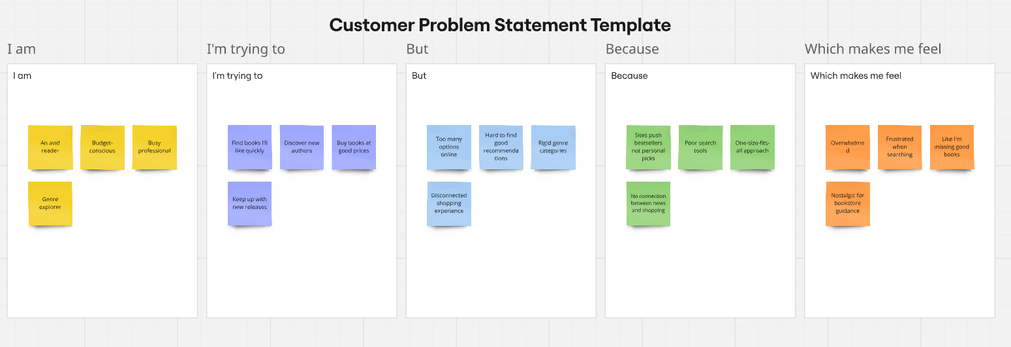

| **Problem Statement (PS)** | **I am (Customer)** | **I’m trying to** | **But** | **Because** | **Which makes me feel** |
| --- | --- | --- | --- | --- | --- |
| PS-1 | An avid reader | Find books I'll like quickly | Too many options online | Sites push bestsellers not personal picks | Overwhelmed |
| PS-2 | Budget-conscious | Discover new authors | Hard to find good recommendations | Poor search tools | Frustrated when searching |
| PS-3 | Busy professional | Buy books at good prices | Rigid genre categories | One-size-fits-all approach | Like I'm missing good books |
| PS- 4 | Genre explorer | Keep up with new releases | Disconnected shopping experience | No connection between news and shopping | Nostalgic for bookstore guidance |

**2.2 Empathy Map Canvas:**

An empathy map is a simple, easy-to-digest visual that captures knowledge about a user’s behaviours and attitudes.

It is a useful tool to helps teams better understand their users.

Creating an effective solution requires understanding the true problem and the person who is experiencing it. The exercise of creating the map helps participants consider things from the user’s perspective along with his or her goals and challenges.

**Example: Book Store Mern Website**

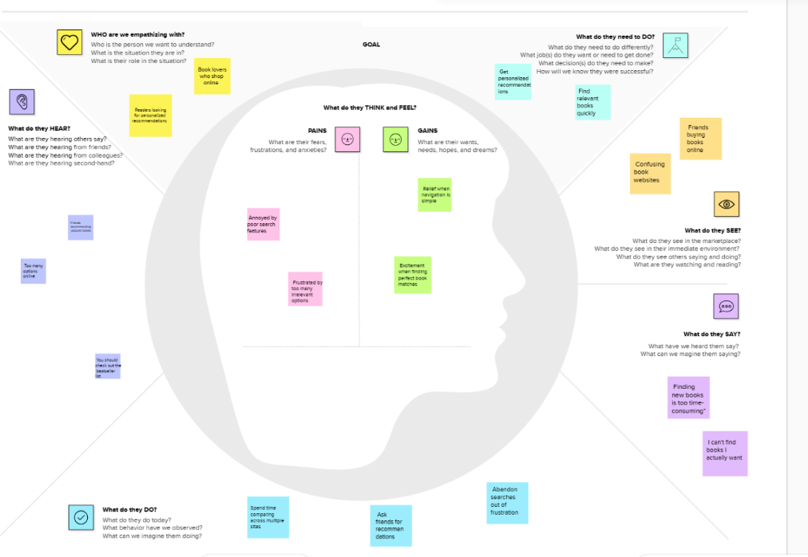

**2.3 Brainstorm & Idea Prioritization :**

Brainstorming provides a free and open environment that encourages everyone within a team to participate in the creative thinking process that leads to problem solving. Prioritizing volume over value, out-of-the-box ideas are welcome and built upon, and all participants are encouraged to collaborate, helping each other develop a rich amount of creative solutions.

Use this template in your own brainstorming sessions so your team can unleash their imagination and start shaping concepts even if you're not sitting in the same room.

Reference: <https://www.mural.co/templates/brainstorm-and-idea-prioritization>

**Step-1: Team Gathering, Collaboration and Select the Problem Statement**

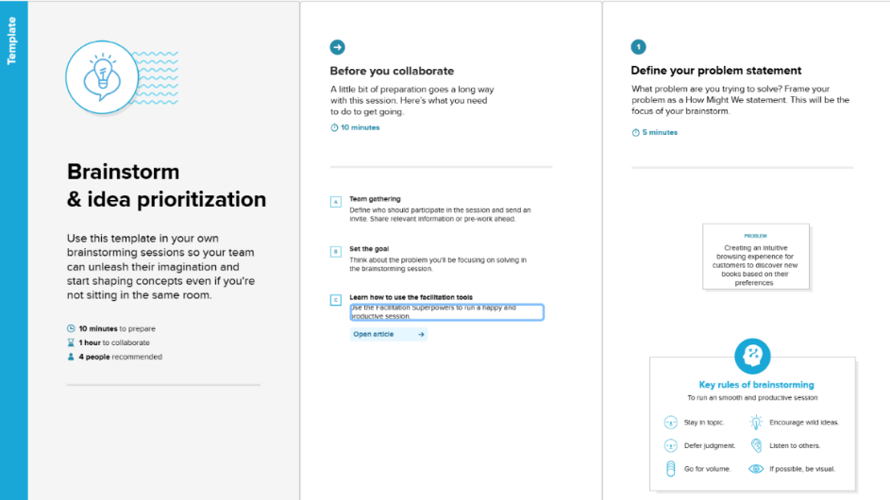

**Step-2: Brainstorm, Idea Listing and Grouping**

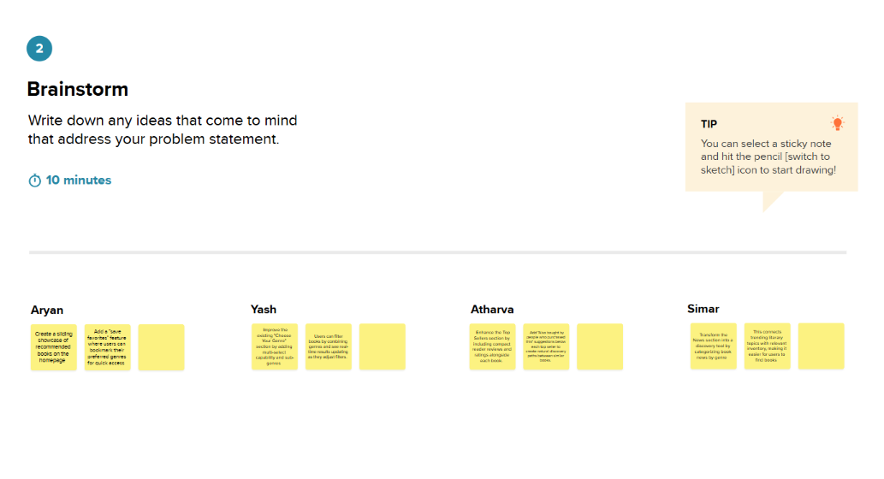

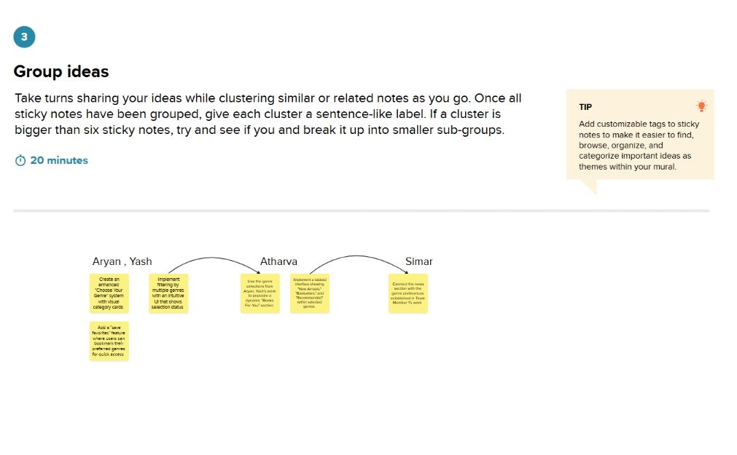

**Step-3: Idea Prioritization**

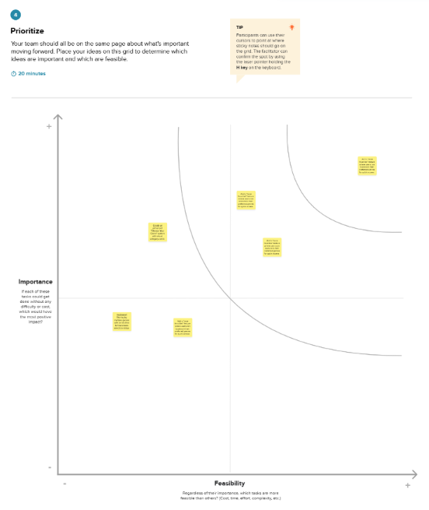

**3 REQUIREMENT ANALYSIS**

| Date | **18 March 2025** |
| --- | --- |
| Team ID | **SWTID1743689974** |
| Project Title | **BookStore** |
| Maximum Marks | **4 Marks** |

**3.1 Customer Journey Map:**

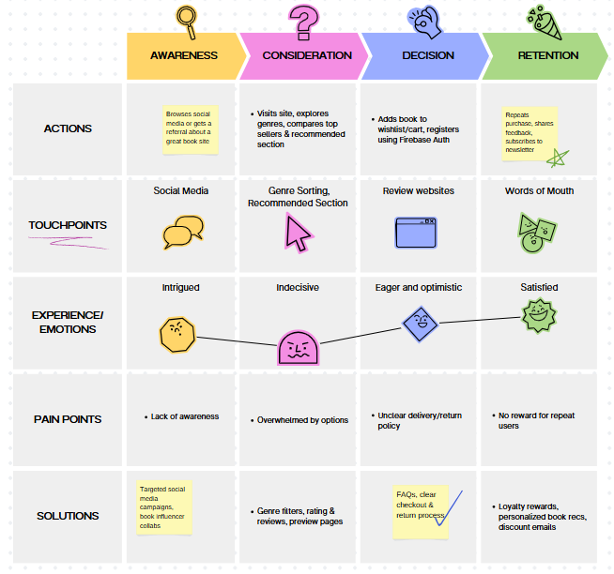

**3.2 Solution Requirements (Functional & Non-functional)**

**Functional Requirements:**

Following are the functional requirements of the proposed solution.

| **FR No.** | **Functional Requirement (Epic)** | **Sub Requirement (Story / Sub-Task)** |
| --- | --- | --- |
| FR-1 | User Registration | Registration through Form Registration through Gmail Role selection (Admin, Seller, Buyer) |
| FR-2 | User Confirmation | Confirmation via Email  Confirmation via OTP |
| FR-3 | | Role-Based Dashboard Access | | --- | | Admin: Manage Users, Books Seller: Upload & Track Books Buyer: Browse, Wishlist, Orders |
| FR-4 | Book Discovery & Browsing | Genre-based sorting Top Seller Page Search by title/author |
| FR-5 | Wishlist & Cart Management | Add to Wishlist Add to Cart Remove from Wishlist/Cart |
| FR-6 | Personalized Experience | Recommended Books Section News Section Updates Top Trending Books |

**Non-functional Requirements:**

Following are the non-functional requirements of the proposed solution.

| **FR No.** | **Non-Functional Requirement** | **Description** |
| --- | --- | --- |
| NFR-1 | **Usability** | Intuitive UI with clear role-based navigation and mobile responsiveness |
| NFR-2 | **Security** | Firebase Auth for secure login, HTTPS communication, JWT protection |
| NFR-3 | **Reliability** | MongoDB Atlas ensures data durability and availability |
| NFR-4 | **Performance** | Fast API response via Node.js and efficient queries with Mongoose |
| NFR-5 | **Availability** | |  | | --- |  | Hosted on scalable cloud (e.g., Render, Vercel, or Firebase Hosting) | | --- | |
| NFR-6 | **Scalability** | Easily extendable with microservices or more collections for large-scale users and books |

**3.3 Data Flow Diagrams:**

A Data Flow Diagram (DFD) is a traditional visual representation of the information flows within a system. A neat and clear DFD can depict the right amount of the system requirement graphically. It shows how data enters and leaves the system, what changes the information, and where data is stored.

**Example:** [**(Simplified)**](https://developer.ibm.com/patterns/visualize-unstructured-text/)

**Flow Sequence:**





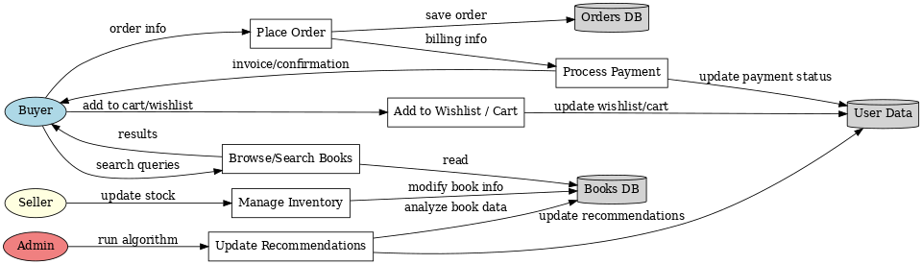

**User Stories:**

| **User Type** | **Functional Requirement (Epic)** | **User Story Number** | **User Story / Task** | **Acceptance Criteria** | **Priority** | **Release** |
| --- | --- | --- | --- | --- | --- | --- |
| Buyer | Registration | USN-1 | As a buyer, I can register and log in using Firebase auth (email/password or Google). | I can access my account/dashboard after successful login. | High | Sprint-1 |
| Buyer | Browse & Sort Books | USN-2 | As a buyer, I can filter books by genres I like. | I can select genres and see sorted books by genre. | High | Sprint-1 |
| Buyer | Recommendations | USN-3 | As a buyer, I can view a recommended books section based on my preferences. | Recommendations display correctly based on interaction/genre. | Medium | Sprint-2 |
| Buyer | Wishlist | USN-4 | As a buyer, I can add books to a wishlist to save them for later. | Books are saved in wishlist and persist after reload. | High | Sprint-2 |
| Buyer | Cart | USN-5 | As a buyer, I can add books to the cart and proceed to checkout. | I can add/remove items from cart and see the cart summary. | High | Sprint-2 |
| Buyer | News | USN-6 | As a buyer, I can see a news section about new arrivals and author updates. | News section displays book-related content. | Low | Sprint-3 |
| Buyer | Top Sellers | USN-7 | As a buyer, I can view a Top Sellers section showcasing most popular books. | Top sellers are displayed based on sales data. | Medium | Sprint-2 |
| Admin | Registration & Auth | USN-8 | As a seller, I can sign up/login using Firebase and manage my listed books. | Seller dashboard becomes available upon login. | High | Sprint-1 |
| Admin | Manage Book Listings | USN-9 | As a seller, I can add, edit, or delete book listings. | CRUD operations work correctly on seller's own books. | High | Sprint-1 |
| Admin | View Sales Metrics | USN-10 | As a seller, I can view sales and performance analytics for my books. | Stats for sales, clicks, etc., appear in seller dashboard. | Medium | Sprint-3 |
| Admin | Manage Users | USN-11 | As an admin, I can view and manage buyer and seller accounts. | Admin dashboard lists all users with manage options. | High | Sprint-1 |
| Admin | Moderate Content | USN-12 | As an admin, I can review and remove inappropriate listings or reviews. | Admin can remove content and see moderation history. | Medium | Sprint-2 |
| Admin | System Dashboard | USN-13 | As an admin, I can view overall platform stats including user activity and sales. | Admin dashboard shows platform-wide metrics. | Medium | Sprint-3 |

**3.4 Technical Architecture:**

The Deliverable shall include the architectural diagram as below and the information as per the table1 & table 2

**Example: Order processing during pandemics for offline mod**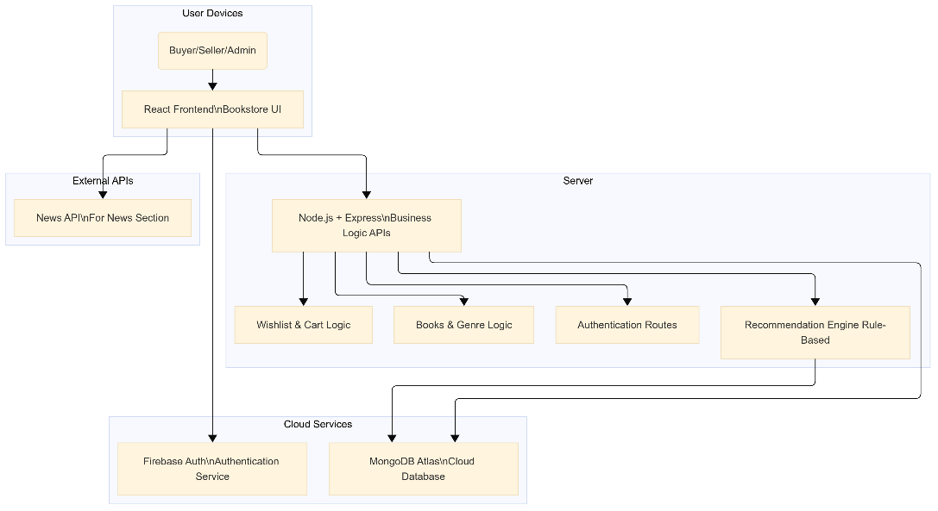



**Table-1 : Components & Technologies:**

| **S.No** | **Component** | **Description** | **Technology** |
| --- | --- | --- | --- |
| 1. | User Interface | Web-based interface for users to interact with the bookstore | HTML, CSS, JavaScript, React.js |
| 2. | Application Logic-1 | User Authentication and Role-based Access Management | Node.js, Firebase Authentication |
| 3. | Application Logic-2 | Book Management (CRUD by Seller/Admin) | Node.js, Express.js |
| 4. | Application Logic-3 | Wishlist, Cart, and Personalized Recommendation Logic | Node.js, Express.js |
| 5. | Database | Stores user profiles, books, wishlist, cart, orders | MongoDB (NoSQL) |
| 6. | Cloud Database | Cloud-hosted database instance | MongoDB Atlas |
| 7. | File Storage | Stores book images and related media | Firebase Storage / AWS S3 / Cloudinary |
| 8. | External API-1 | Book Metadata / Book Cover fetch (Optional) | Google Books API |
| 9. | External API-2 | News updates related to books/literature | NewsAPI.org / NY Times Books API |
| 10. | Infrastructure (Server/Cloud) | Deployed on cloud platform for scalability | Render / Vercel for frontend Railway / Heroku for backend |

**Table-2: Application Characteristics:**

| **S.No** | **Characteristics** | **Description** | **Technology** |
| --- | --- | --- | --- |
| 1. | Open-Source Frameworks | Utilizes widely adopted open-source technologies for frontend, backend, and database management | React.js, Node.js, Express.js, MongoDB, Tailwind CSS |
| 2. | Security Implementations | Firebase Authentication for access control, HTTPS for secure data transfer, route protection | Firebase Auth, JWT, HTTPS, Firebase Rules, Helmet.js |
| 3. | Scalable Architecture | 3-tier architecture (Frontend-Backend-Database) with cloud deployment for horizontal scaling | MERN Stack, Render/Vercel, MongoDB Atlas (auto-scaling) |
| 4. | Availability | Hosted on cloud with automatic failover and high availability using distributed architecture | MongoDB Atlas (multi-region), Render, Firebase Hosting |
| 5. | Performance | React virtual DOM for fast UI rendering, API caching, CDN for static files, optimized queries | React.js, Express.js, MongoDB indexes, Vercel CDN |

**4 Project Design Phase**

| Date | 20 March 2025 |
| --- | --- |
| Team ID | **SWTID1743689974** |
| Project Title | Bookstore |
| Maximum Marks | 2 Marks |

**4.1 Problem – Solution Fit:**

The Problem-Solution Fit simply means that you have found a problem with your customer and that the solution you have realized for it actually solves the customer’s problem. It helps entrepreneurs, marketers and corporate innovators identify behavioral patterns and recognize what would work and why

**Purpose:**

* Solve complex problems in a way that fits the state of your customers.
* Succeed faster and increase your solution adoption by tapping into existing mediums and channels of behavior.
* Sharpen your communication and marketing strategy with the right triggers and messaging.
* Increase touch-points with your company by finding the right problem-behavior fit and building trust by solving frequent annoyances, or urgent or costly problems.
* **Understand the existing situation in order to improve it for your target group.**

**Example:**

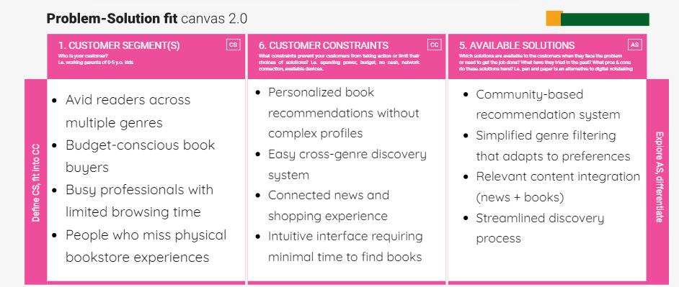

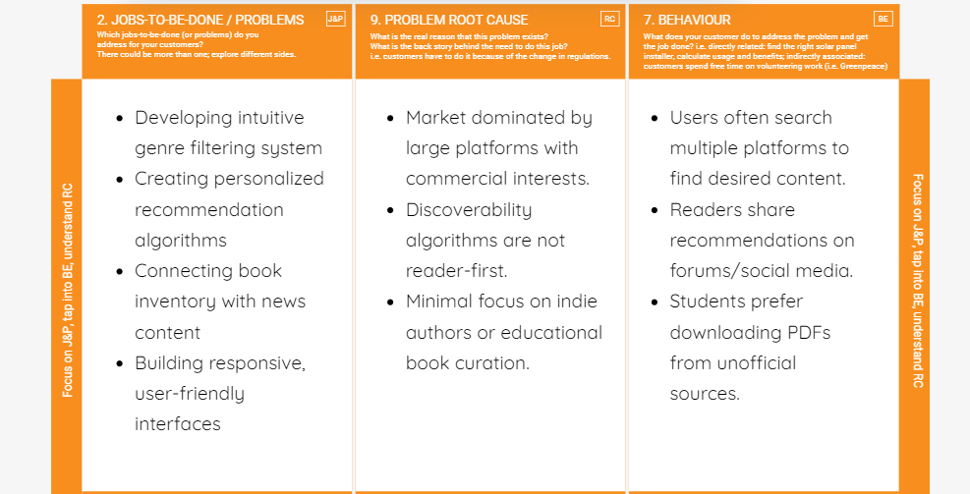

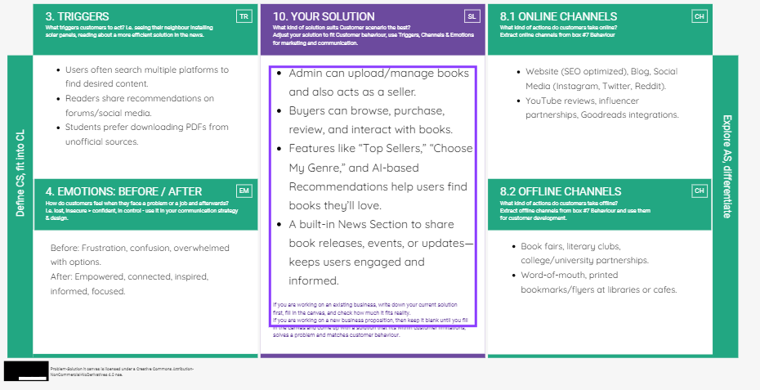

**4.2 Proposed Solution**

Project team shall fill the following information in the proposed solution template.

| **S.No.** | **Parameter** | **Description** |
| --- | --- | --- |
| 1 | Problem Statement (Problem to be solved) | Traditional bookstores and many online platforms lack personalized user experiences, flexible seller management, and intuitive discovery features. Sellers struggle to reach targeted audiences, and buyers face difficulty in navigating large catalogs. |
| 2 | Idea / Solution Description | A MERN-stack bookstore platform with Firebase authentication and MongoDB Atlas. The site includes role-based dashboards for Admin, Seller, and Buyer. Key features: Top Seller Page, Genre Filtering, Recommended Section, News Section, Wishlist, and Add to Cart functionality. |
| 3 | Novelty / Uniqueness | Role-based dashboards for each user type, personalized book recommendations, dynamic genre sorting, real-time updates via news, and seamless cart/wishlist system in one full-stack platform. |
| 4 | Social Impact / Customer Satisfaction | Helps promote reading by making books more discoverable and affordable, empowers small sellers with online tools, and improves user satisfaction with personalization and ease of use. |
| 5 | Business Model (Revenue Model) | Revenue generated through seller commissions, subscription plans for premium listing features, affiliate marketing, and targeted advertising for books and authors. |
| 6 | Scalability of the Solution | Hosted on scalable platforms like Firebase and MongoDB Atlas. Easily extensible to handle more users, books, and features. Can support mobile apps and multi-language expansion in future. |

**4.3 Solution Architecture:**

**Key Objectives:**

* Secure user authentication and role-based access (Admin , Buyer)
* Scalable database with books, orders, users, and recommendations
* Personalized experience through genre filtering and wishlists

**Core Components:**

* **Frontend**: React.js – handles UI, dynamic rendering based on user role
* **Authentication**: Firebase – manages login/signup and user roles
* **Backend API**: Node.js + Express – processes business logic and routes
* **Database**: MongoDB Atlas – stores all data (users, books, orders, etc.)
* **Recommendations Engine**: Based on genres, user history
* **News Feed**: Dynamically fetched via external API or admin uploads
* **Wishlist & Cart**: Stored per user with real-time update support

**Solution Architecture Diagram:**

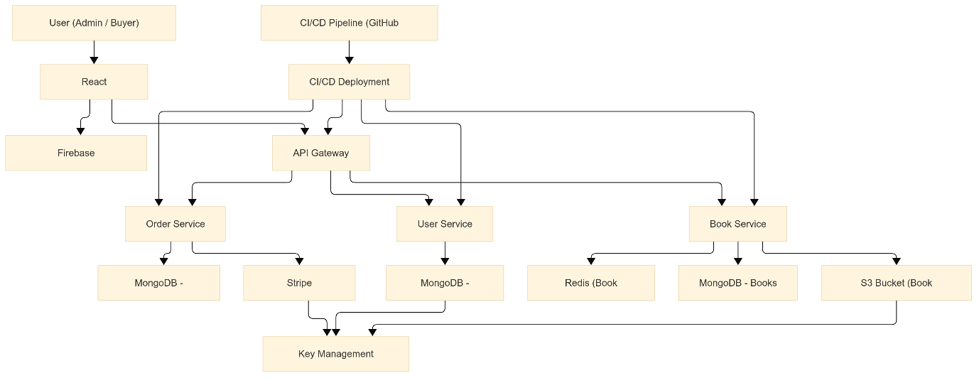

*Figure 1: Architecture and data flow of the Bookstore website*

**5 PROJECT PLANNING AND SCHEDULING**

**5.1 Project planning**

| Date | **23 March 2025** |
| --- | --- |
| Team ID | **SWTID1743689974** |
| Project Title | **Bookstore** |
| Maximum Marks | **5 Marks** |

**Product Backlog, Sprint Schedule, and Estimation:**

| **Sprint** | **Functional Requirement (Epic)** | **User Story Number** | **User Story / Task** | **Story Points** | **Priority** | **Team Members** |
| --- | --- | --- | --- | --- | --- | --- |
| Sprint-1 | Registration | USN-1 | As a user, I can register by entering my email, password, and confirming my password. | 2 | High | **Simar** |
| Sprint-1 | Confirmation | USN-2 | As a user, I will receive a confirmation email once I register. | 1 | High | **Simar** |
| Sprint-2 | Registration | USN-3 | As a user, I can register using Facebook. | 2 | Low | **Simar** |
| Sprint-1 | Registration | USN-4 | As a user, I can register using Gmail. | 2 | Medium | **Simar** |
| Sprint-1 | Login | USN-5 | As a user, I can log in using email and password. | 1 | High | **Aryan** |
| Sprint-1 | Dashboard Setup | USN-6 | As a user, I can view a basic homepage/dashboard UI after login. | 2 | High | **Aryan** |
| Sprint-1 | Wishlist Functionality | USN-7 | As a buyer, I can add/remove books from my wishlist. | 3 | Medium | **Atharva** |
| Sprint-1 | Cart Functionality | USN-8 | As a buyer, I can add/remove books from my cart. | 3 | Medium | **Atharva** |
| Sprint-2 | Genre Filtering | USN-9 | As a user, I can filter books based on genre selection. | 3 | High | **Yash** |
| Sprint-2 | Top Sellers Section | USN-10 | As a user, I can view a list of top-selling books. | 3 | High | **Yash** |
| Sprint-2 | News Section | USN-11 | As a user, I can view news related to books fetched from external API. | 2 | Medium | **Aryan** |
| Sprint-2 | Recommended Books Section | USN-12 | As a user, I can view book recommendations on homepage. | 3 | High | **Atharva** |

**Total Story Points: Sprint-1 = 14, Sprint-2 = 13**

**Project Tracker, Velocity & Burndown Chart: (4 Marks)**

| **Sprint** | **Total Story Points** | **Duration** | **Sprint Start Date** | **Sprint End Date (Planned)** | **Story Points Completed** | **Sprint Release Date (Actual)** |
| --- | --- | --- | --- | --- | --- | --- |
| **Sprint-1** | **14** | **6 Days** | **24 March 2025** | **29 March 2025** | **14** | **29 M 2025** |
| **Sprint-2** | **13** | **6 Days** | **31 March 2025** | **05 April 2025** | **13** | **05 April 2025** |
| **Sprint-3** | **20** | **6 Days** | **07 April 2025** | **12 April 2025** | **TBD** | **TBD** |
| **Sprint-4** | **20** | **6 Days** | **14 April 2025** | **19 April 2025** | **TBD** | **TBD** |

**Velocity :**

* Total Story Points Completed (Sprint 1 + 2) = 14 + 13 = 27
* Total Sprints Completed = 2
* Velocity per Sprint = 27 / 2 = 13.5
* Average Velocity per Day = 13.5 / 6 ≈ 2.25 Story Points/day

**Burndown Chart:** 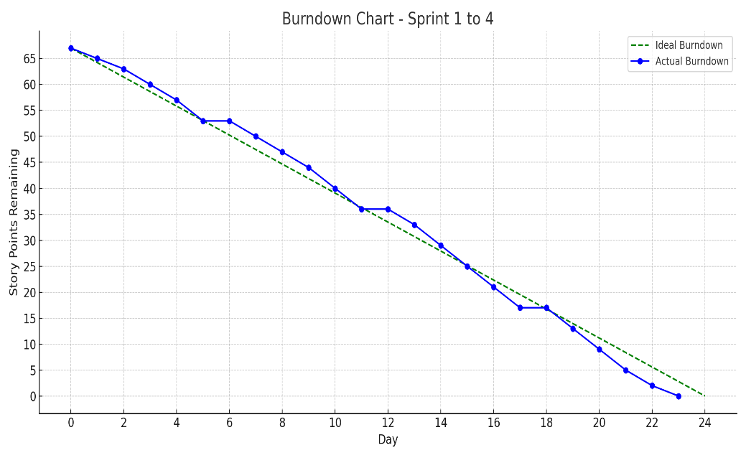

A burn down chart is a graphical representation of work left to do versus time. It is often used in agile[software development](https://www.visual-paradigm.com/scrum/what-is-agile-software-development/) methodologies such as [Scrum](https://www.visual-paradigm.com/scrum/scrum-in-3-minutes/). However, burn down charts can be applied to any project containing measurable.

**6 Functionality and Performance testing**

| Date | **10-04-2025** |
| --- | --- |
| Team ID | **SWTID1743689974** |
| Project Title | **BookStore** |
| Maximum Marks | **10** |

**6.1 User Acceptance Testing (UAT)**

**Project Overview**

* **Project Name: MERN Bookstore Platform**
* **Project Description:**A robust, full-stack MERN (MongoDB, Express.js, React.js, Node.js) web application designed for an online bookstore supporting Firebase Authentication and MongoDB Atlas integration. The system accommodates three distinct user roles (Admin, Seller, Buyer), providing a comprehensive user experience that includes genre-based browsing, top-selling books, personalized recommendations, editorial news content, a wishlist module, and a shopping cart system.
* **Project Version: 1.0.0**
* **Testing Period: April 1, 2025 – April 10, 2025**

**Testing Scope**

**Features and Functionalities to be Tested:**

* Firebase-based user authentication and session management
* Role-based access control and authorization
* Book browsing and filtering by genre
* Dynamic "Top Sellers" page rendering and ranking logic
* AI-based or algorithmic "Recommended for You" section
* Editorial/News blog integration and content delivery
* Wishlist functionality (add/remove/view)
* Shopping cart management (add/edit/delete/quantity updates)
* Seller/admin book listing management interface
* Data flow validation between client, server, and MongoDB Atlas
* Responsive design compatibility across devices and browsers

**User Stories to be Validated:**

* Users can authenticate and retain session via Firebase securely.
* Buyers can navigate and filter books by chosen genres.
* Buyers can interact with and manage wishlist and cart items.
* Admins/sellers can upload and manage book entries.
* Buyers can view and interact with recommendation logic and top-selling titles.
* News section loads dynamically with valid editorial entries.
* All user flows comply with functional and UI/UX design expectations.

**Testing Environment**

* Deployment URL:<https://book-store-frontend-sigma-beige.vercel.app/>
* Tech Stack: React.js (frontend), Express.js & Node.js (backend), MongoDB Atlas (database), Firebase (auth)
* Credentials (if required):
  + Admin: admin@test.com / password123
  + Buyer: buyer@test.com / password123

**Test Cases**

| **Test Case ID** | **Test Scenario** | **Test Steps** | **Expected Result** | **Actual Result** | **Pass/Fail** |
| --- | --- | --- | --- | --- | --- |
| TC-001 | Firebase Authentication | 1. Navigate to login page 2. Enter valid credentials 3. Submit form | User is redirected to dashboard with correct role access | [To be filled] | [To be filled] |
| TC-002 | Book Genre Filtering | 1. Navigate to homepage 2. Select genre from dropdown 3. View filtered results | Books are displayed based on selected genre | [To be filled] | [To be filled] |
| TC-003 | Add to Wishlist | 1. Log in as buyer 2. Click "Add to Wishlist" on a book 3. Check Wishlist page | Book appears in wishlist | [To be filled] | [To be filled] |
| TC-004 | Add to Cart | 1. Log in as buyer 2. Click "Add to Cart" 3. View Cart page | Book is listed in cart with default quantity | [To be filled] | [To be filled] |
| TC-005 | Recommended Books Section | 1. Navigate to homepage 2. View recommended section | Books are dynamically populated based on logic or user history | [To be filled] | [To be filled] |
| TC-006 | Top Seller Page | 1. Navigate to "Top Sellers" page | Books are listed based on sales ranking logic | [To be filled] | [To be filled] |
| TC-007 | News Section Rendering | 1. Navigate to "News" section | Editorial/blog content is displayed with proper formatting | [To be filled] | [To be filled] |

**Bug Tracking**

| **Bug ID** | **Bug Description** | **Steps to Reproduce** | **Severity** | **Status** | **Additional Feedback** |
| --- | --- | --- | --- | --- | --- |
| BG-001 | Wishlist not updating on item removal | 1. Add book to wishlist 2. Remove from wishlist 3. Refresh page | Medium | Open | State not syncing with database |
| BG-002 | "Top Sellers" sorting not accurate | 1. Navigate to top sellers 2. Compare actual sales data | High | In Progress | Logic discrepancy in sort function |

**Sign-Off**

* Tester Name: [Insert Name]
* Date of Test Completion: [Insert Date]
* Signature: [Insert Digital Signature or Initials]

**Notes:**

* Ensure that all test cases cover both positive and negative scenarios.
* Encourage testers to provide detailed feedback, including any suggestions for improvement.
* Bug tracking should include details such as severity, status, and steps to reproduce.
* Obtain sign-off from both the project manager and product owner before proceeding with deployment.

**7 Results**

**Output ScreenShots:**

**User Login Page:**

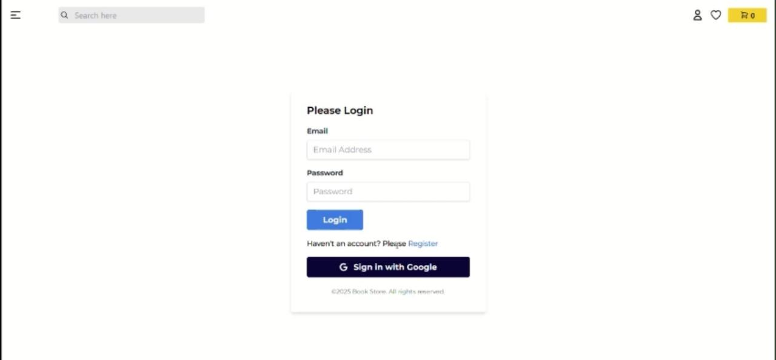

**Banner section:**



**Top seller section:**



**Recommendation Section:**



**News and footer section:**

**Add to Cart section:**

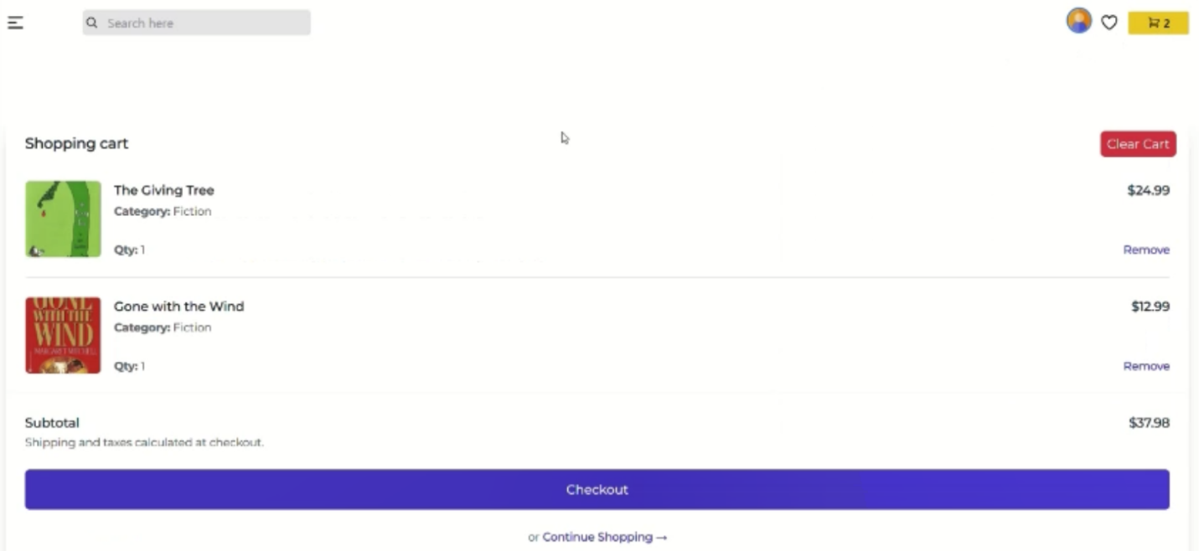

**Checkout Section:**

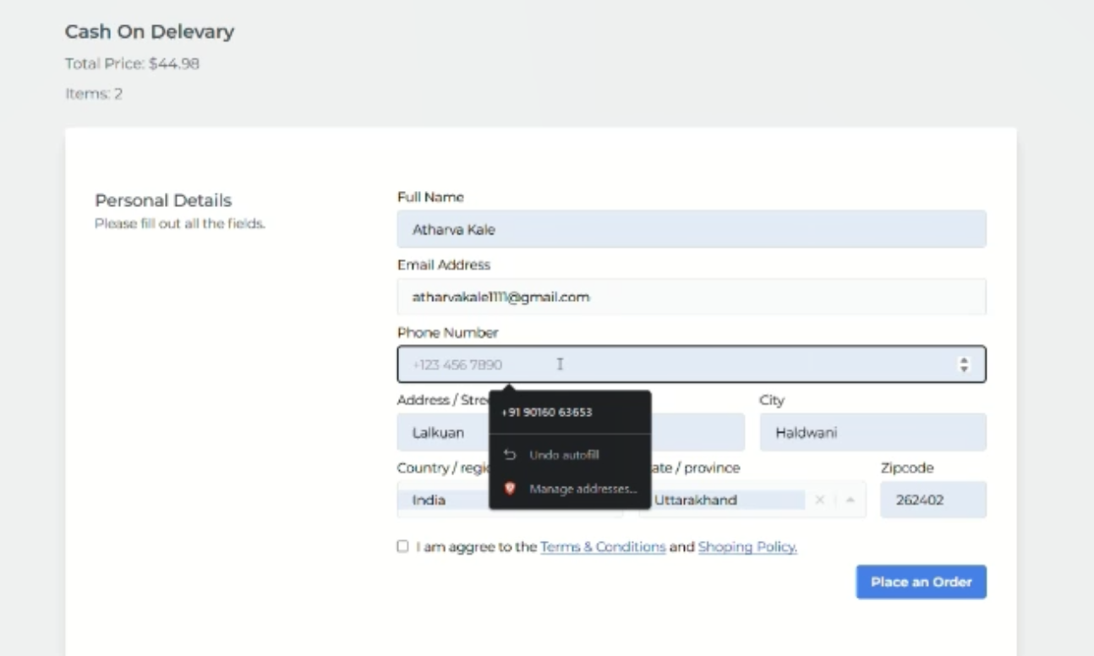

**Your orders Section:**

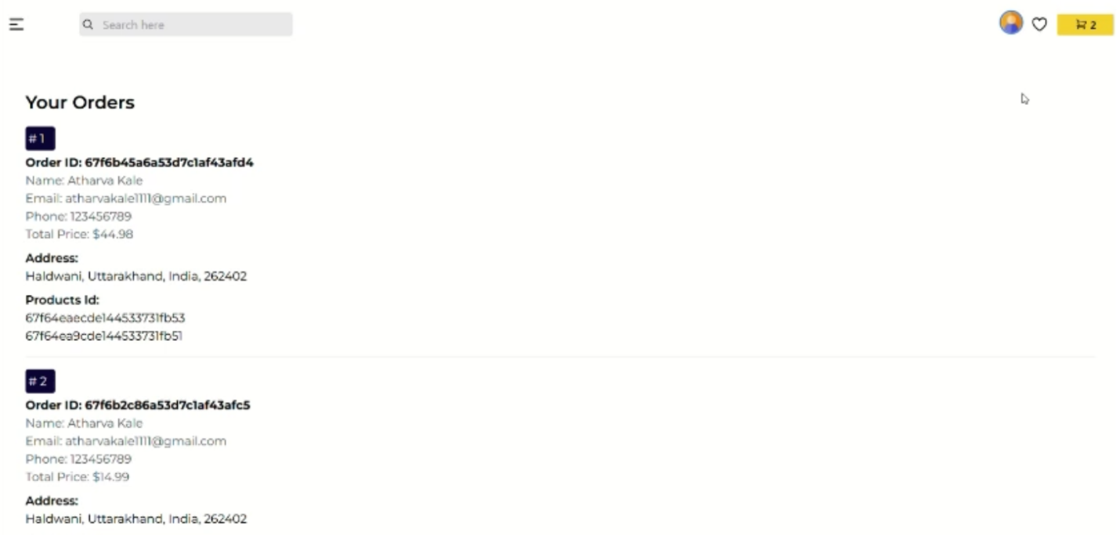

**Admin Login:**

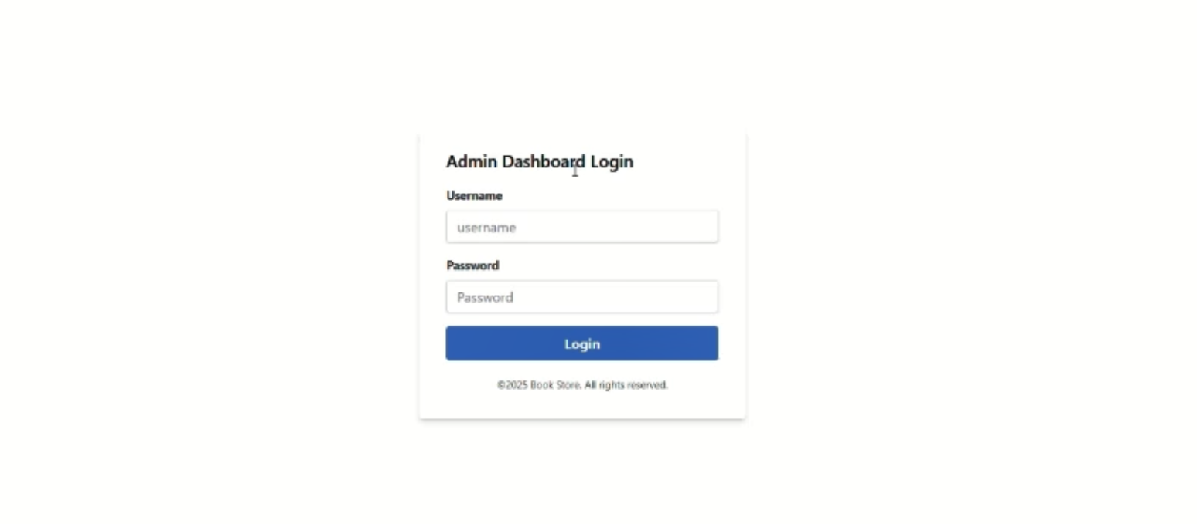

**Admin Dashboard:**

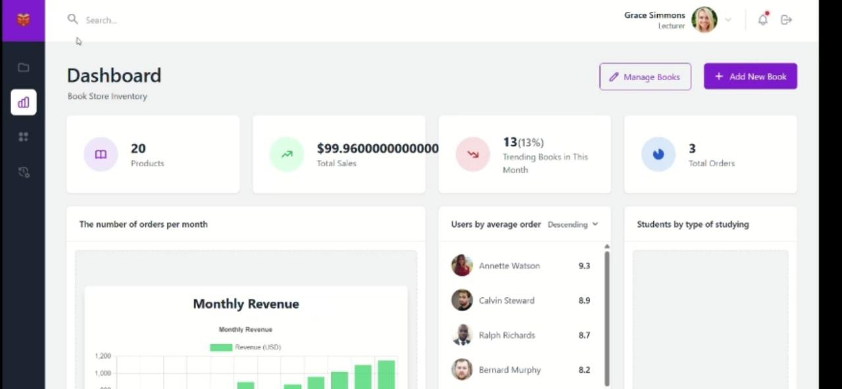

**Update and Add functionality:**

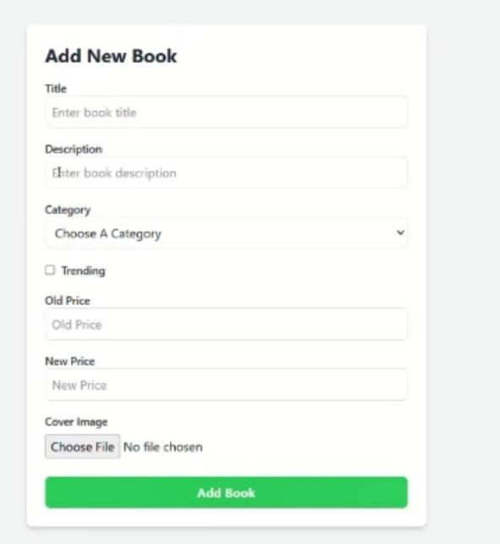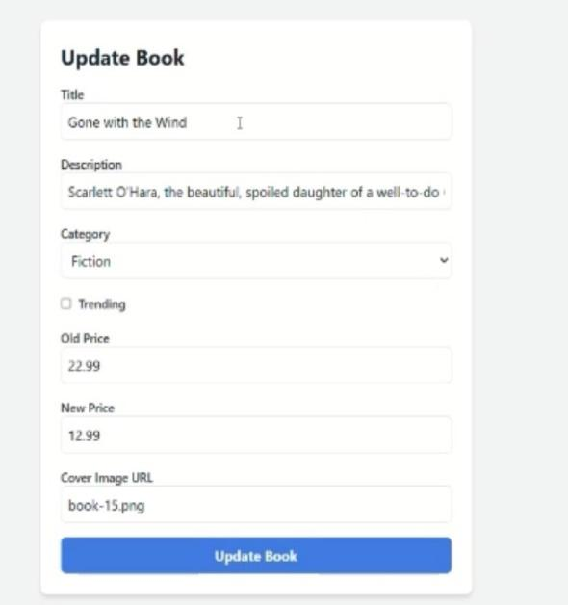

**Admin Actions:**

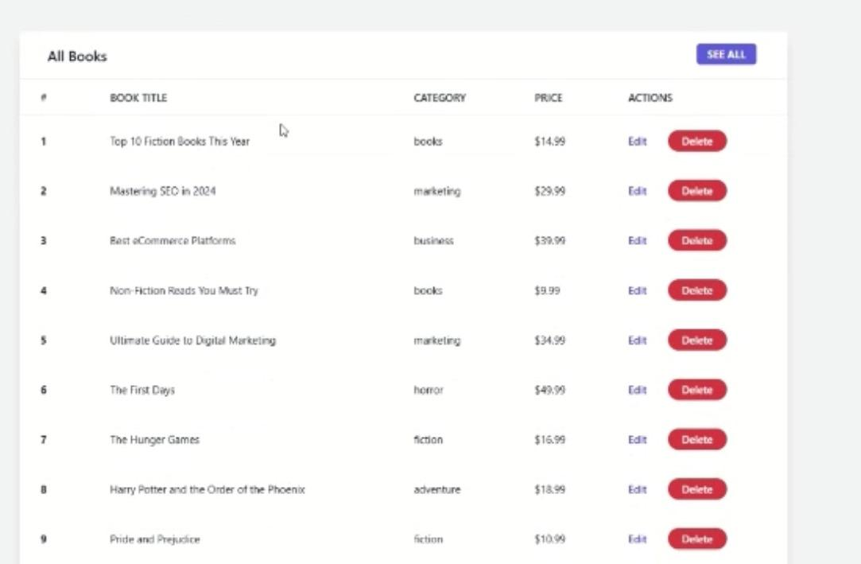

**8 ADVANTAGES AND DISADVANTAGES**

**Advantages:**

1. **Unified JavaScript Stack** - Using JavaScript throughout the entire application (MongoDB, Express, React, Node.js) simplifies development and allows for better team collaboration with a common language.
2. **Real-time User Experience** - MongoDB and React's virtual DOM enable efficient data handling and UI updates, creating a responsive experience for book browsing, cart management, and checkout.
3. **Scalability** - MongoDB Atlas provides cloud-based database scaling that can accommodate growing book catalogs and increasing user numbers without performance degradation.
4. **Authentication Security** - Firebase integration offers robust, production-ready authentication systems with features like social logins and multi-factor authentication without building these security components from scratch.
5. **Component Reusability** - React's component-based architecture allows for creating reusable UI elements (book cards, search filters, cart items) that maintain consistency while reducing development time.
6. **JSON Data Structure** - The MERN stack uses JSON format throughout, enabling seamless data transfer between frontend, backend, and database without format conversions.
7. **Rich Ecosystem** - Access to extensive libraries and tools from the Node.js and React communities provides solutions for common e-commerce features like payment processing, image handling, and search functionality.

**Disadvantages:**

1. **Learning Curve** - The MERN stack requires proficiency in multiple technologies, potentially extending development time for team members unfamiliar with all components.
2. **Performance Challenges** - JavaScript's single-threaded nature in Node.js can impact performance for CPU-intensive operations like complex search algorithms or large report generation.
3. **Security Considerations** - NoSQL databases like MongoDB require careful implementation of security practices as they lack the built-in security features of traditional relational databases.
4. **State Management Complexity** - As the application grows, managing state across numerous React components can become increasingly complex, potentially requiring additional libraries.
5. **MongoDB Limitations** - Complex transactions involving multiple collections (e.g., inventory updates with order processing) require careful implementation compared to SQL databases with native transaction support.
6. **Initial Setup Overhead** - Configuring the full stack environment, connecting services like Firebase and MongoDB Atlas, and establishing proper project structure requires significant initial investment.
7. **Version Compatibility** - Keeping all components of the MERN stack and their dependencies up-to-date without breaking changes can be challenging.

**9 Conclusion**

**Conclusion:**

The MERN Stack Bookstore project represents a modern, feature-rich e-commerce solution tailored specifically for selling books online. By leveraging MongoDB, Express.js, React, and Node.js, the application delivers a cohesive user experience while providing powerful administrative tools for inventory management.

This project successfully integrates key functionalities essential for an online bookstore, including personalized recommendations, top seller showcases, new arrivals features, comprehensive shopping cart capabilities, and seamless checkout processes. The dual-role system accommodates both customers and administrators, ensuring each user type has access to the tools and information they need.

The integration of Firebase for authentication and MongoDB Atlas for database management provides a solid foundation for security and scalability. While there are some inherent challenges in the MERN stack implementation—including potential complexity in state management and performance considerations for certain operations—the advantages significantly outweigh the disadvantages for this specific use case.

The responsive design approach ensures the bookstore remains accessible across a variety of devices, expanding market reach and enhancing user satisfaction. As the application grows, the modular architecture will accommodate new features and scaling requirements, making this a sustainable solution for the long term.

With careful attention to user experience, security best practices, and performance optimization, this MERN Stack Bookstore delivers a compelling online platform that connects readers with books while simplifying inventory management for sellers.

**10 FUTURE SCOPE**

**Future Scope:**

The MERN Stack Bookstore platform has significant potential for expansion and enhancement. Future development could focus on the following areas:

1. Advanced Search and Filtering - Implement natural language processing and AI-powered search algorithms to help users find books based on themes, writing style, and content similarity rather than just keywords.
2. Personalization Engine - Develop a sophisticated recommendation system using machine learning algorithms that analyze user browsing history, purchase patterns, and reading preferences to suggest highly relevant books.
3. E-book Integration - Expand beyond physical books to offer e-books with secure digital rights management, preview capabilities, and a built-in e-reader experience within the platform.
4. Audiobook Support - Incorporate audiobook offerings with streaming functionality, bookmarking features, and integration with popular audio platforms.
5. Subscription Service - Implement a membership model offering discounts, exclusive content, early access to new releases, or unlimited reading options for digital content.
6. Community Features - Create book clubs, discussion forums, and reading challenges to foster user engagement and build a community around shared reading interests.
7. Author Marketplace - Develop functionality for independent authors to self-publish and sell their works directly to readers, potentially expanding into print-on-demand services.

**11 APPENDIX**

**Github Link:** <https://github.com/SimarKochar/bookstore-mern.git>

**Demo Video Link:**

<https://drive.google.com/drive/folders/1K7_2aklT689re6swvisdBFRsYanfM2zz?usp=drive_link>

**DriveLink:**<https://drive.google.com/drive/folders/1kL2sqYrcl1ZwutTpIZC7-vcnzuCwyl7x?usp=sharing>